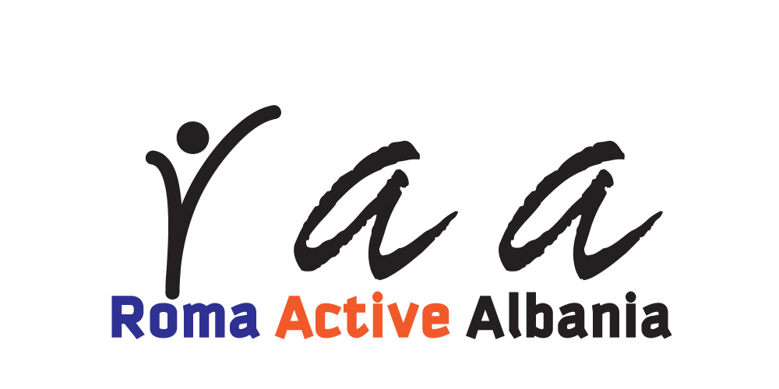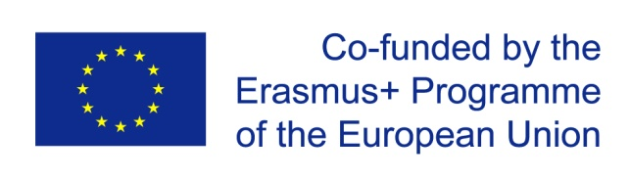

SEMINAR

Fighting Antigypsyism through grassroots actions

Durres, ALBANIA

May 20-27- 2016

(arrival day 20th of May, and 27th of May is departure day)

PARTICIPANT INFORMATION
Family name:  Given name: M F |  | Information for visa:  Nationality:  Place of birth:  Passport number:  Date of issue:  Date of expiry:  Issued by:
Date of birth (dd/mm/yy):

Street address:
Postal code:
Town:
Country:
Telephone: |  | Emergency contact information:  Name:  Tel:  Email:
Mobile: |  | Emergency contact information:  Name:  Tel:  Email:
Email: |  | Emergency contact information:  Name:  Tel:  Email:
SPECIAL NEEDS
Allergies:  Food restrictions: | Injuries:  Health problems or sicknesses:

Your organisation

Name
Complete address
Postal code |  | Town |  | Country
Phone  [with full international dial codes] |  |  | Fax  [with full international dial codes]
Email |  |  | Website
Activity level | local regional national international

Please describe briefly your organization and your projects
What are the objectives, main activities and target group of your organization?
What is your role (volunteer, youth leader/worker, manager, supervisor, coordinator ...) and your tasks within projects in organization? Please say how long you have been involved in projects in your organization?
In your organization, do you work with young people with fewer opportunities? Please describe in more details experience you have.

MOTIVATION & EXPECTATIONS
What would you like to learn, understand and experience during this seminar?

What contributions can you bring for this seminar?
How do you plan to use the outcome of this activity in your work?

SIGNATURE
DATE AND PLACE:
SIGNATURE:

Participants are expected to make the cheapest travel arrangements and to check the travel costs with the organisers, before purchasing the tickets!!!

