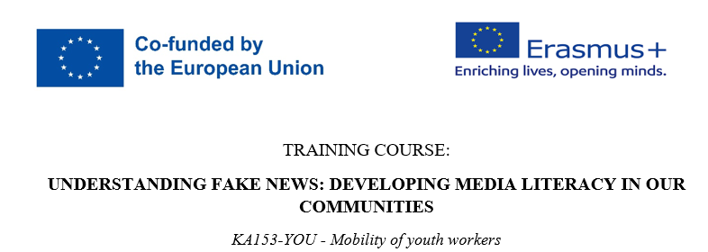
05.-13.11.2023.
Nova Gradiška, Croatia

APPLICATION FORM

PART I - PERSONAL DETAILS
Name
LAST NAME
DATE OF BIRTH |  |  |  |  |  | GENDER
COUNTRY OF RESIDENCE
ADRESS
MOBILE NR.
E-MAIL
FACEBOOK PROFILE (LINK) (if available)
PASSPORT/ID NUMBER |  |  |  |  | Date of issue:
 |  |  |  |  | Date of expiration:
PART II – CONTACT PERSON
Name
LAST NAME
COUNTRY OF RECIDENCE
ADRESS
MOBILE NUMBER
E-MAIL
ROLE
PART III – Practicalities
Special requirements upon fewer oportunities
Meal preferences (diet, allergies, vegan, etc)
English skills  (mark) |  | 5 fluent | 4 average | 3 basic |  |  | 2 poor |  | 1 very poor
Please select the fewer opportunity category, if available.
(Description: https://www.salto-youth.net/tools/otlas-partner-finding/help/young-people-with-fewer-opportunities/)
Anything else you think organisers need to know?
PART IV – PROFFESIONAL detailes & EXPERIENCE
ORGANISATION
YOUR ROLE IN THE ORGANISATION (IF APPLICABLE)
YOUR DAILY JOB/OCUPATION
PART V – MOTIVATION
Why you want to participate in this TC?
What are your expectations regarding this TC?
Have you ever participated in a similar course (YIA / E+ training courses or other non formal education programmes)? If yes, please provide some details.
How you will use the new competences you will develop here in the TC after the project?
How will the NGO support you to use these competences?

Please send the application form to the contact person from the partner NGO from your country. For questions, don’t hesitate to send us an email at udruga.zazeli@gmail.com

Remember, this application will help the trainers and facilitators to better shape the course according to the profile, the interests and the need of the participants. So, please, fill all the boxes!
See you soon in Croatia

